This document outlines preliminary outcomes from PCXMC testing
Summary
ICRP103 | effective dose (mSv)
protocol | 180cm 88kg | 150cm 50kg | 200cm 150kg
head | 0.50 | 0.82 | 0.28
Pelvis | 4.24 | 4.44 | 1.80
Breast360 | 0.24 | 0.29 | 0.14
H&N/Shoulders | 0.26 | 0.29 | 0.20
Thorax | 1.31 | 1.87 | 0.87

Files for PCXMC (excel and the program itself) located in C:\PCXMC (WESHONC-ECL0007). Program for multiple fields (like CBCT) are run from the spreadsheet through VB code (ctrl+A runs program ‘First’, ctrl+B runs program ‘Second’, ctrl+C runs program ‘Third). Run all three programs to calculate and import results. Then sum first and third results column (see existing excel spreadsheets for examples). ’PCXMC program puts two sets of files out, the first goes into C:\PCXMC\MCRUNS and the second goes into your nominated folder (mine was C:\PCXMC\MCRUNS\TP).
HEAD
First round of experiments went from 0 degrees (Lt lateral) to 200 degrees past Rt lateral via back of the head. Uses 5cm averages at iso of the beam profiles measured by IJ.
Z=88 means that the projected beam height of 21.4 is just at the top of the head (see images below)
For 20 projections gives the following effective dose
ICRP103 – 0.3894mSv
ICRP60 – 0.338mSv
Change #1 – increased number of projections
To investigate if we are using enough projections, change the amount used
For 50 projections gives the following effective dose
ICRP103 – 0.3876mSv – 0.45% different to 20 projections
ICRP60 – 0.3372mSv – 0.21% different to 20 projections
Ie Sweet FA.
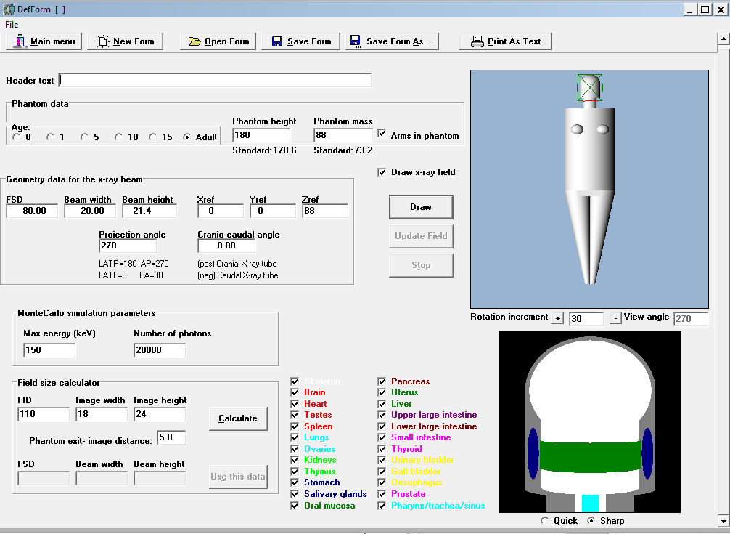
Change #2 – lowered the beam 3cm to z=85cm
To investigate how sensitive the location is, lowered the beam by 3cm inf (see images below, might include thyroid)
For 20 projections gives the following effective dose
ICRP103 – 0.4904mSv – 26% different z=88cm
ICRP60 – 0.4178mSv – 24% different to z=88cm
Ie whole lotta FA (lots of %’s, not much absolute).
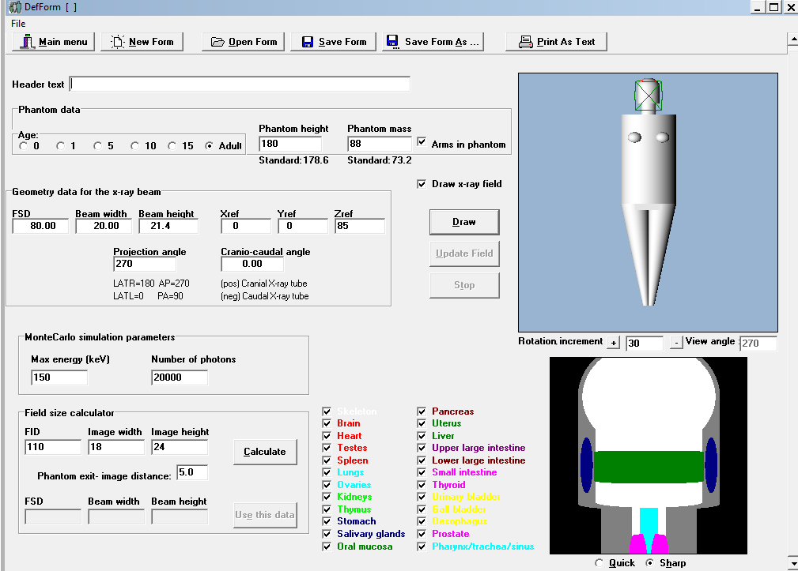

Change #3 – changed rotational direction of the beam
To investigate if the opposite direction exposing the eyes to entrance dose would change dose, counter-clockwise rotation
For 20 projections gives the following effective dose
ICRP103 – 0.6307mSv – 62% different clockwise
ICRP60 – 0.4759mSv – 41% different to clockwise
Ie bigger %, so don’t irradiate the eyes/nasal cavity, gives good dose to sensitive organs, try for exit dose to eyes etc only

Change #4 – changed the profile averaging of the kV output from 5cm to 3cm
To investigate if the grouping of beam profiles measured by IJ changes if we go from 5cm averaging to 3cm averaging
For 20 projections gives the following effective dose
ICRP103 – 0.3909mSv – 0.4% different
ICRP60 – 0.3413mSv –1.0% different
This took very similar time to calculate, possibly better to go with finer averaging.
Change #4 – Final arrangement
Using the right profile and only between the blades of the kV source
For 20 projections gives the following effective dose
ICRP103 – 0.50mSv – 0.4% different
ICRP60 – 0.42mSv –1.0% different

Pelvis
Centred at z=5, includes gonads and uterus and ovaries (yes all in 1 model). This scan isn’t half fan, see the results down the bottom for half fan.
For 20 projections gives the following effective dose
ICRP103 – 5.04mSv
ICRP60 – 8.14mSv
Change #1 – increased number of projections
To investigate if we are using enough projections, change the amount used
For 50 projections gives the following effective dose
ICRP103 – 5.06mSv – 0.4% different to 20 projections
ICRP60 – 8.16mSv – 0.2% different to 20 projections
Ie Sweet FA.
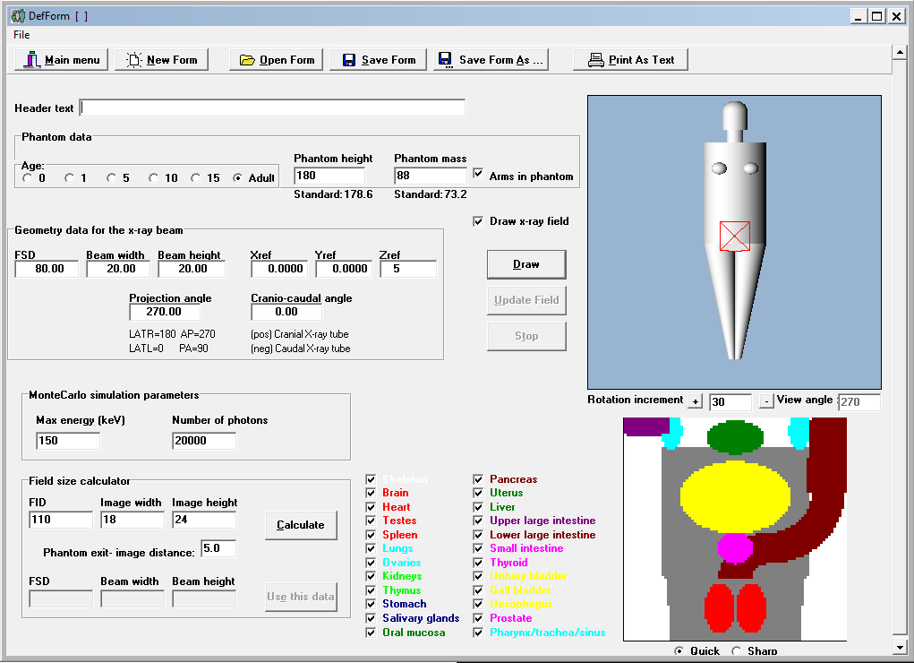

Change #2 – changed the profile averaging of the kV output from 5cm to 3cm
To investigate if the grouping of beam profiles measured by IJ changes if we go from 5cm averaging to 3cm averaging
For 20 projections gives the following effective dose
ICRP103 – 5.01mSv –0.6% different to 5cm averaging
ICRP60 – 8.12mSv –0.2% different to 5cm averaging

Change #3 – changed the direction using a 5cm averaging beam
This is a 360 beam, changing direction should mean nothing different for exposure
For 20 projections gives the following effective dose
ICRP103 – 5.049mSv –0% different to other direction
ICRP60 – 8.135mSv –0% different to other direction

Change #4 – pelvis scan is actually offset, not central as defined by the collimation
This is the configuration that is actually used.
This is a 360 beam, with beam definition between -5 and +25cm.
For 20 projections gives the following effective dose
ICRP103 – 4.848mSv – 4.0% different (lower) central beam
ICRP60 – 7.816mSv – 3.90% different (lower) central beam

Change #5– offset in wrong direction above (use this answer as correct simulation technique)
This is the configuration that is actually used.
This is a 360 beam, with beam definition between +5 and -25cm.
For 20 projections gives the following effective dose
ICRP103 – 4.24mSv
ICRP60 – 6.92mSv

Breast 360
Centred at z=50,
Average female for Australia 165cm tall and 72kg
For 20 projections gives the following effective dose
ICRP103 –0.37mSv
ICRP60 –0.32mSv
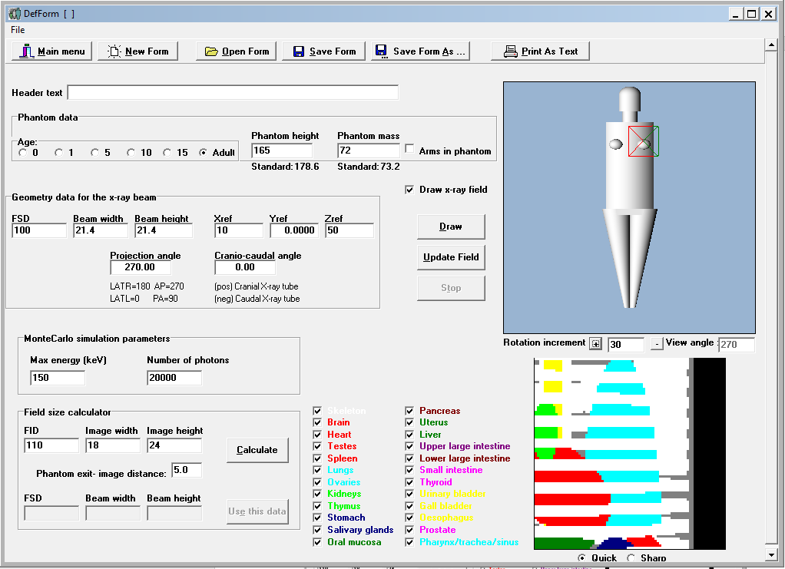

Change #1 – increased number of projections
To investigate if we are using enough projections, change the amount used
For 50 projections gives the following effective dose
ICRP103 – 0.37mSv –0.0% different to 20 projections
ICRP60 – 0.32mSv –0.0% different to 20 projections
Ie Sweet FA.
Change #2 – Measurements of the field were incorrect (full fan) needed to be half fan
Scaled from pelvis, half fan, right number of projections, arms up etc
For 20 projections gives the following effective dose
ICRP103 – 0.24mSv
ICRP60 – 0.20mSv

Head/Neck/shoulders
Centred at z=82, field is half fan, centre of field is 10cm from central axis of phantom. Field definition goes from +5cm to -25cm. did some mAs scaling for Pelvis to generate to the data for the head/neck/shoulders protocol
Average male for Australia 180cm tall and 88kg
For 20 projections gives the following effective dose
ICRP103 –0.391mSv
ICRP60 –0.355mSv
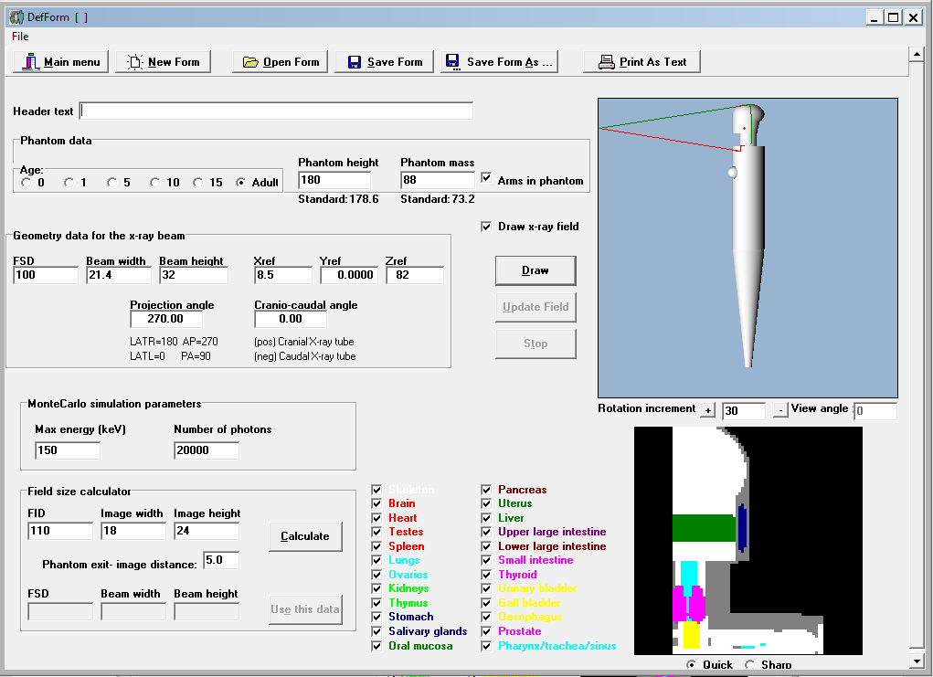

Change #1 – final change. Measured data was wrong, scaled pelvis (mAs) used for beam data
Discussed with RT the amount of extended H&N scans that are done. Response was they aren’t. Utilized the 21.4cm Y-direction blades as the extent of field, setup the field to encompass the thyroid and most of the head.
For 20 projections gives the following effective dose
ICRP103 – 0.26mSv
ICRP60 – 0.23mSv

Thorax
Centred at z=54, field is half fan. Field definition goes from +5cm to -25cm. did some mAs scaling for Pelvis to generate to the data for the thorax protocol.
Average male for Australia 180cm tall and 88kg
For 20 projections gives the following effective dose with arms up
ICRP103 –1.71mSv
ICRP60 –1.48mSv

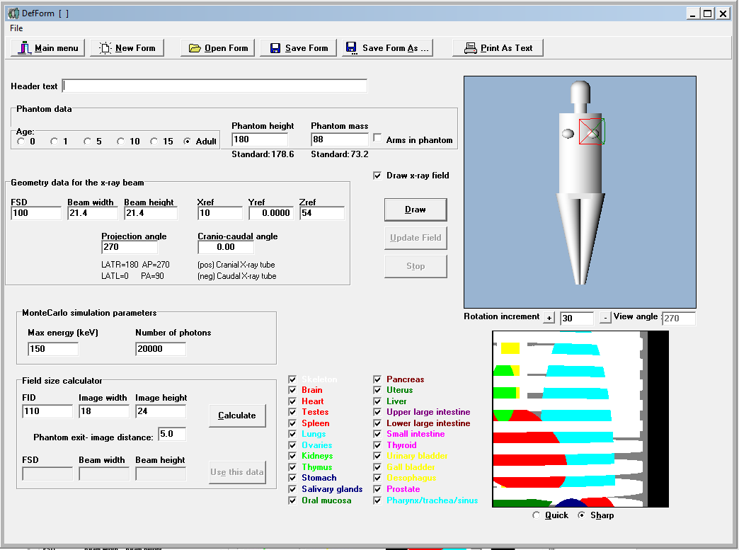

Change #1 – arms down
To investigate if arms up/down option makes a difference
For 20 projections with arms down gives the following effective dose
ICRP103 – 1.65mSv –3.6% different to arms down
ICRP60 – 1.42mSv –4.0% different to arms down

Change #2 – changed the profile averaging of the kV output from 5cm to 3cm
To investigate if the grouping of beam profiles measured by IJ changes if we go from 5cm averaging to 3cm averaging. This was for older data and hence the values are shit
For 20 projections gives the following effective dose
ICRP103 – 2.24mSv –1.6% different to 5cm averaging
ICRP60 – 2.05mSv –1.9% different to 5cm averaging

Advice for using the matlab code and measurement spreadsheets
The matlab code that ends with ‘_final.m’ in the name was used to produce the results at the top of this document. Average male is 180cm tall and 88kg, average female was 165cm tall and 72kg. 150cm tall 50kg person was simulated and 200cm 150kg person. the differentiation is in the file name to make it easy to discern.
Angle zero such as the starting point is the gantry 90 position and this is the location of the kV source. Direction of rotation is viewed from the couch and specified 0=clockwise, 1=counterclockwise. Other angles are defined as
0 is LtLateral imaging
90 is AP
180 is RtLateral
270 is PA
pWidth is half the total body width which is centred at (0,0). -Y direction is anterior, yes minus Y. +Y is posterior. -X is patient right, +X is patient left. pDepth is the Ant/post (-Y/+Y) direction.
When simulating head, pHeadRadii2 is the back of the head I think. The back of the head is smaller than the front and you’ll notice from the simulations that there is a occipital lobe like back end where the neck is quite thin in comparison, this will throw errors if you choose a pHeadRadii2 that is too big, errors are a pain in the posterior as they make you manually OK them, meaning sitting there while it calculates.
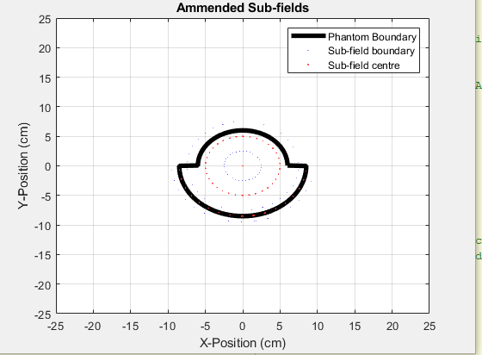
Found only a small difference between 50 projections vs 20 projections (~1%) so went with 20 projections to save time.
Updated Aarons original code to allow different directions of rotation and start/end points to suit. Commented the heck out of it, changed some things that were throwing errors (made hospital number a consecutive number, rounded angles for PCXMCInput as the names of files used these angles and caused obscure errors. Added comments to help the next generation figure out what to manually change in the spreadsheet, save you reading the documentation as much.
Measurement spreadsheets for CBCT data
They are a bit of an enigma sorry….
The fields were measured without the blades in the appropriate position for that scan protocol. This means the data set is wider than the actual field.
“New test August” has the measured data from IJ/JB.
Measurement were in uGy/s and needed to be converted to mGy/frame for PCXMC. This was done by taking the uGy/s and dividing by the number of frames/s. frames/s are on the relevant protocol tab (ie Head, Pelvis etc). On each protocol tab is also the blade positions Y1/Y2 are sup/inf, X1/X2 are ant/post (might have mixed 1/2 around).
Protocol tabs also have the kV and mAs.
mAs was required to scale some of the measurements, this is where it gets a little more confusing. Pelvis measurements were used to scale Head and Shoulders/Neck and thorax and Breast360 measurements. The values used for simulation weren’t from the top of the spreadsheet where all the other measurement data is, we used the bottom right of the spreadsheet, read the title for each section. Ie if you read Breast 360 measurements they are full fan but in reality they are half fan.
For more reliable setting info, look for TrueBeamCBCTmodes.xlsx to compare and contrast data, when you get totally confused, go to the linac setup the field an take a picture.
To see if the partitioning of data made any difference, the measured data was broken down into 5cm sub-fields, what the heck is a subfield I hear you ask…. Because the air kerma per frame is different across the field and PCXMC accepts only quantized values we have to do something like the following (just to highlight the concept) to allow the curve to be approximated.
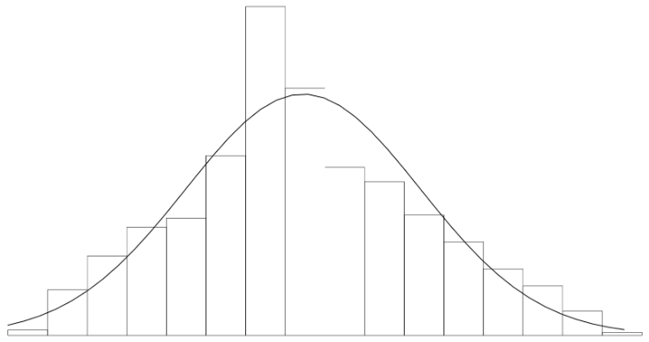
To investigate the number of bins required, did 5cm bins and 3cm bins. They made bugger all difference. 5cm wide bins were quicker, we went with those.
Binning was of course repeated for the overall equivalent mmAl. mmAl didn’t get scaled from Pelvis.

